**USE CASE DIAGRAM**

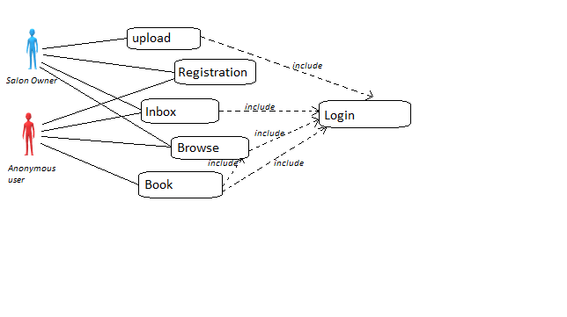**ANONYMOUS USER USE CASE**

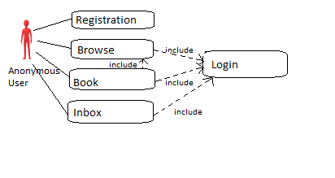

**Use Case:** Registration, Browse, Book or Inbox **Brief Description:** Anonymous user registering, browsing or booking on the application **Step By Step Description:**   
1. Registration details may be entered by the anonymous user  
2. Anonymous user will click the “Register” button to register  
-----------------------Or---------------------------  
1. Anonymous user can log into the app and browse all the photos of the hairstyles, also the salons around them  
-----------------------Or---------------------------  
1. Anonymous user can log into the app, select a salon and book

**SALON OWNER USER CASE**

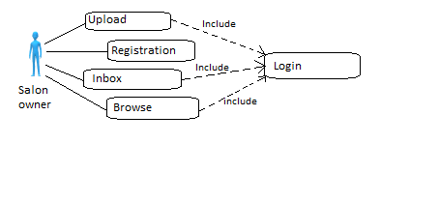

**Use Case:** Upload, Register or browse **Brief Description:** the salon owner registering, browsing or uploading photos on the application **Step By Step Description:**1. Salon owner can register their salon on the app by entering their details and the salon’s name  
2. Salon owner can enter the salon’s address  
-----------------------Or---------------------------  
1. The salon owner can upload pictures of hair styles  
2. The salon owner can upload pictures of the environment  
-----------------------Or---------------------------  
1. The salon owner can browse the hairstyles and check the reviews of customers